**UVSim Main Page**

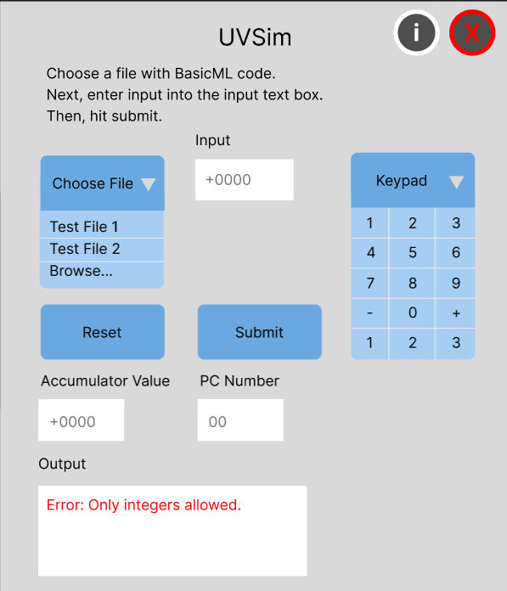

The output textbox will show all console output. Errors will be in red as demonstrated. Successful program execution output will be printed in black. I was thinking any extra notifications would go here too but we could also include pop ups for those as needed.

1. **Quit Pop-Up**

When you hit the red ‘X’, this pop-up will appear on the screen:

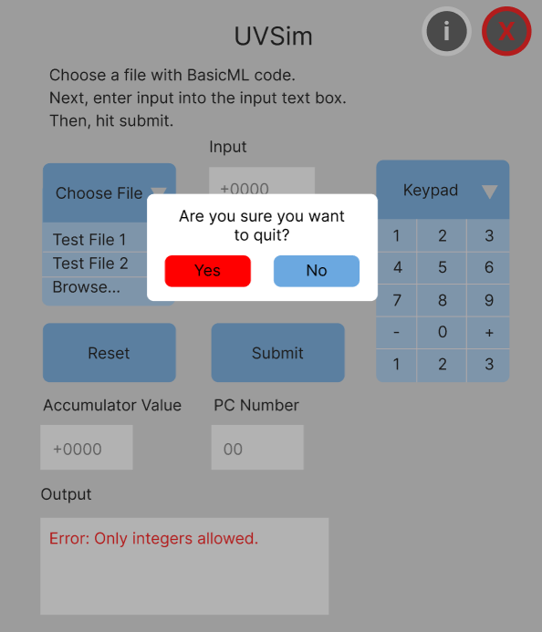

1. **Information Screen**

When you hit the “i” button, it will take you to this screen: 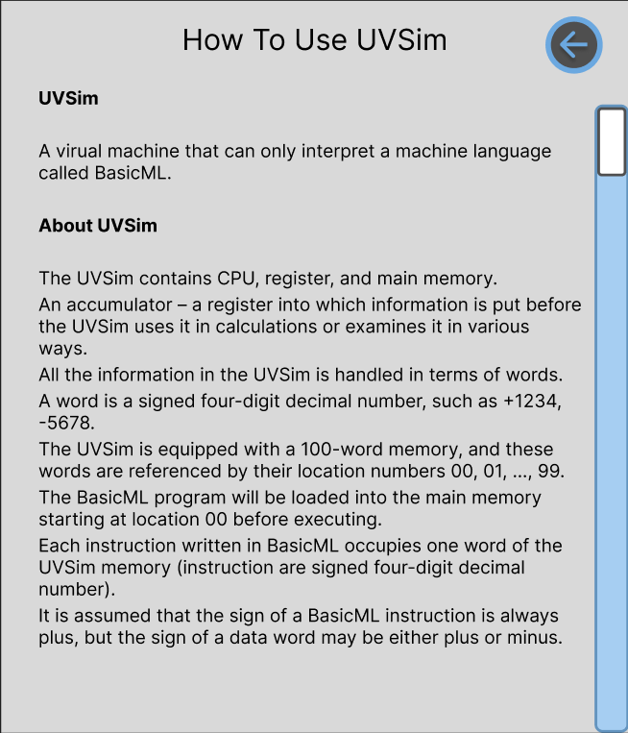

This will give all the same information that our README doc has. The user shouldn’t have to go back and forth to the README doc to figure out how our app works (imo).

There is a scrollbar on the right so that not all the info has to fit on a single page. Another option (if it is easier), would be to make arrows at the bottom, for page turns.

1. **Second Iteration - Information Screen**

Lastly, the README doc has quite a bit of information. Perhaps it would be more user friendly to break it up into sections:

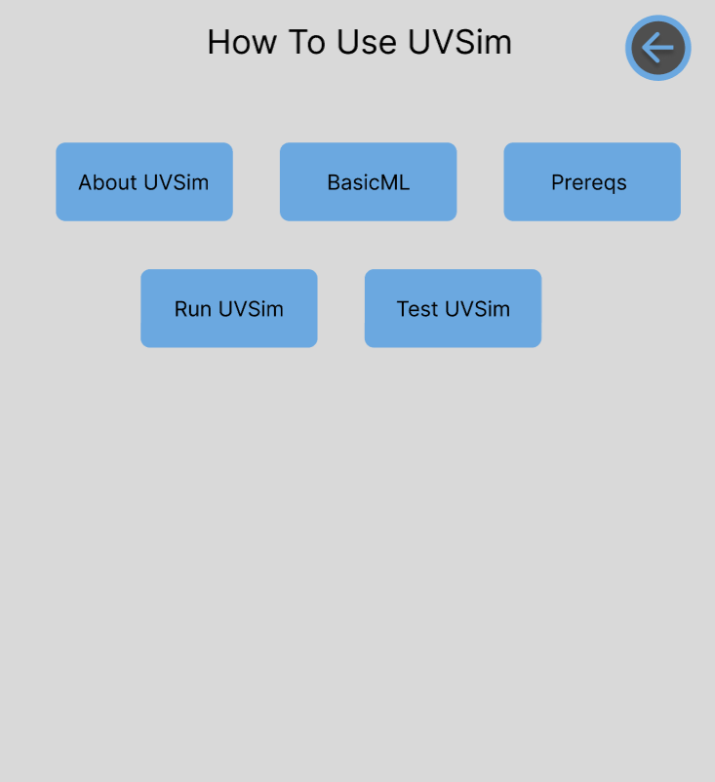

You could click on whatever section you need at any given time.

I personally don’t think we should implement this part until the next sprint just for time’s sake. However, it might be nice to add later on, so one doesn’t have to scroll through loads of text.